Chapter 8, Problem 16.

Find i(t) for t > 0 in the circuit of Fig. 8.70.

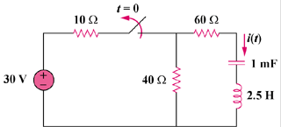

Figure 8.70
For Prob. 8.16.

